Nathan Alexander

Squeezing Spread Cities:
Improving the energy efficiency of large cities

A summary of a study of the same name,
undertaken as part of the
Master of Arts in Urban Design,
Oxford Polytechnic

October 1990

Improving the efficiency of the use of energy is important: it increases the ability to adapt to change; it improves competitiveness in the international marketplace of the telecommunications age; it increases the environmental sustainability of cities; and it is more equitable to future generations. Almost half the people of the world live in cities, and more than half the energy used is consumed there. ^{(Brown and Jacobson, 1987)} Urban form influences about half or more of the energy demand in large cities in advanced industrial societies, the main users, so it is a signiﬁcant field for energy efficiency. (Barton, 1987:7; Lundqvist 1989:5)

The study that this article summarizes analyses the inﬂuence of aspects of urban form on energy demand within large cities in the advanced industrial societies and identiﬁed characteristics that improved energy efficiency. It found great scope for reducing the energy demand of urban form without detracting from physical amenity of cities. Potential efficiencies are in many cases twice as high as that achieved at present. (Barton 1987 fig. 4.3; Owens 1986:68: Lundqvist 1989:10) Substantial reductions in energy demand thus seem feasible in the long term. However, due to the nature of cities, improving the energy efficiency of urban form is a slow, incremental process that requires considerable planning and design for best effect.

The study places the aim of improving the energy efficiency of urban form within the context of a wider approach to urban design, that of the range of choices available to the users of cities. The values and urban forms of the Responsive Environments approach ^{(Bentley and others, 1985)} and the energy efficiency approach were examined for possible conflicts and similarities and found to be in broad agreement. Energy efficiency is an integral aspect of the quality of robustness. The availability of energy in the future is uncertain. The more energy efficient an environment is, the more adaptable it is to changes in the energy supply.

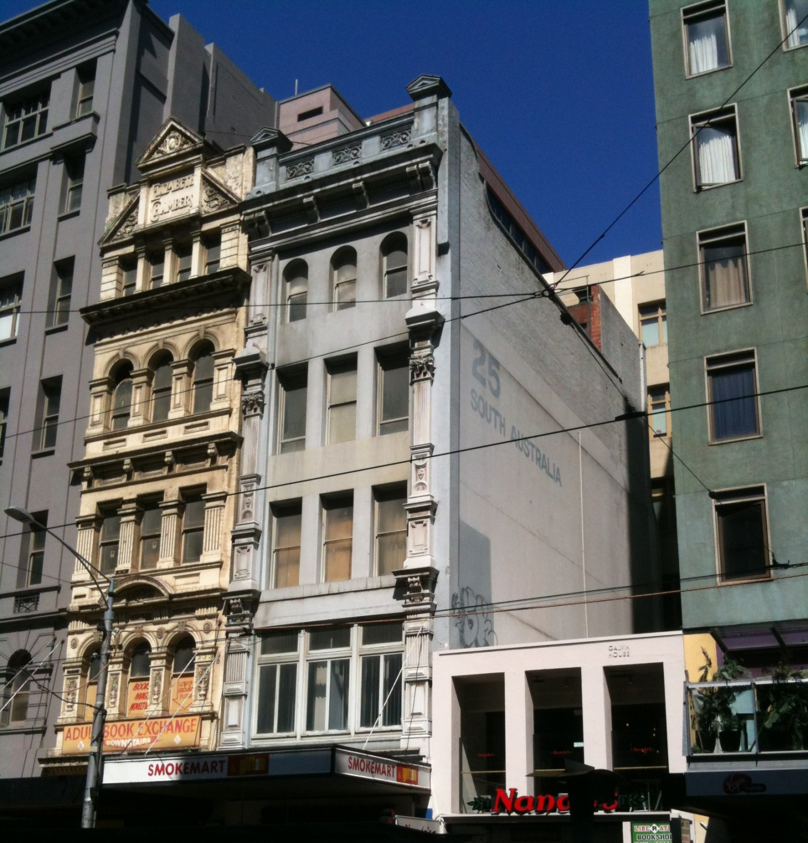

In the high energy cities of the advanced industrial societies, urban form achieves best energy efficiency by firstly minimising energy demand and secondly and less importantly by collecting ambient energy. Transport and space heating and cooling are the most significant elements of energy demand. (Chapman, 1975; DITR, 1988; DEA, 1988) Energy demand for transport is minimised when walking, cycling and public transport are the foremost means of travel. This is promoted by urban form with a high density of residences and workplaces, and with services and employment being as localized as their function permits. Energy demand for heating and cooling is reduced by buildings sharing walls and having less external surface. Ambient energy is useful for space heating, lighting and ventilation within buildings, and for growing food and drying clothes in outdoor areas.

Urban environments that maximize energy efficiency have the following characteristics:

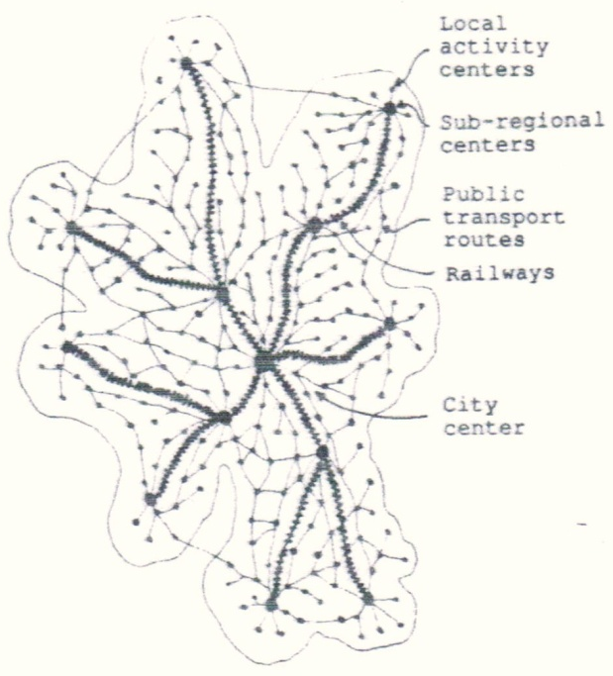
At the scale of metropolitan structure
- Facilities grouped together into activity centers.
- Activity centers arranged in a hierarchy from small local ones with common facilities to large regional centers with specialized facilities.
- Public transport linking the activity centers to each other, and especially to those further up the hierarchy.
- Sub-regional centers linked to the city centre by rail transport on dedicated rights-of-way.
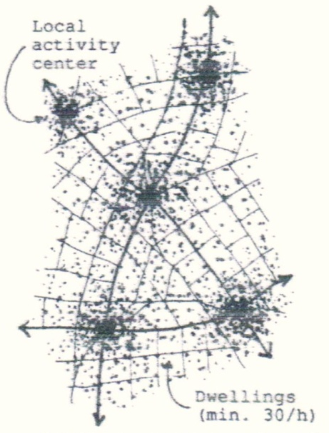
At the scale of local areas
- Local facilities such as grocery stores, pubs and cafes, and schools grouped into local activity centers.
- All residences within easy walking distance of a local activity centre.
- Population density increases towards activity centers.
- A gross residential density of at least thirty dwellings to the hectare, and probably more than seventy-ﬁve to the hectare.
- Priority in the use of circulation space given in the order of footpaths, cycle paths, public transport routes, private motorized vehicles.
- Local streets serving dual roles as circulation space and as recreational space.
At the scale of individual facilities
- Facilities provided at as small a scale as possible.
- Facilities able to be adapted to other functions.
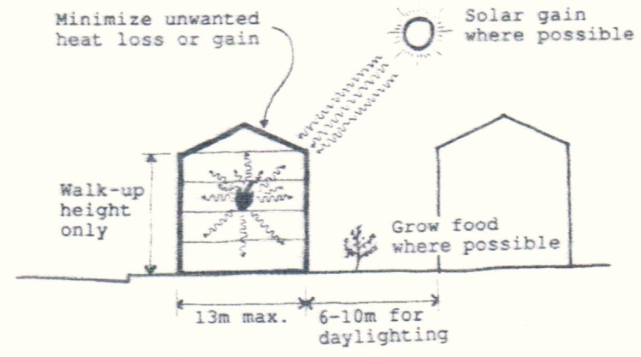
- All buildings of walk-up height and shallow depth unless this is unsuitable for the function to be accommodated.
- Most buildings attached to neighbours in a row at least eight long.
- Building form first reduces unwanted heat loss or gain, secondly collects solar energy.
- Dwellings are able to be expanded.
- Food plants grown where space permits.

The most important priorities for improving the energy efficiency of existing urban form in advanced industrial societies is:
- To increase population density - "squeezing the city";
- To shift the proportion of trips within the city away from the use of private motorized vehicles towards walking, bicycling and public transport; and
- To attach buildings to one another.
Implementation of these and other measures to improve the energy efficiency of urban form involves all the actors making decisions about a city’ s environment. This includes private organizations and the people of the area as individuals. However the most important actor is government: not only is it a major constructor and user of urban form, but it has power to control the developments of the other actors. The methods that government can use are explored in the study.

The two cities examined in depth in the study because of their energy planning - Davis, California and Copenhagen, Denmark - came to that involvement through an initial concern for social welfare and environmental quality. They see energy efficiency as an essential component to achieving their broader objectives.

Davis is a small university town in California that has dramatically reduced energy consumption since a new General Plan was introduced in 1973. It demonstrates what can be done to improve urban form in a very short time if social conditions are favourable. ^{(Phileo, 1981)} This was done as part of an successful attempt to improve the general living quality of Davis. No great conflict has arisen between the energy objectives and other objectives in the course of the attempt.

Copenhagen demonstrates urban form with a comparatively high degree of energy efficiency and a large degree of amenity. Until the 1970's the energy efficiency occurred largely without deliberate intent, but since then has been a conscious objective of the government. Journeys to work, at an average trip length of 7.5 kms, are almost equally split three ways between cars, public transport, and walking and cycling. (Newman and Kenworthy, 1989:225) Population density averages 30.4 people per hectare, (Newman and Kenworthy, 1989:192, 301) with fully or partially attached dwellings over 98% of the housing stock. ^{(Hovedstatsradet, 1985)}

In light of the experiences of Davis and Copenhagen and the potential for government to act, the study describes the urban form of Melbourne, Australia, a city typical of many car-dependent low-density cities lacking policies on energy efficiency, and suggests how it can become more energy efficient. Average journey to work length is 13.7 km, with over seventy-three percent of workers using cars for the purpose. (Newman and Kenworthy, 1989:319) Population density is only 16.4 people per hectare . (Newman and Kenworthy, 1989:301) and more than three-quarters of all dwellings are fully detached houses. (ABS, 1986) The state planning policies are conducive to energy efficiency, but the local government ones are not. The most significant actions the government could take to improve the energy efficiency of Melbourne’s urban form are:
- To assess the energy use of proposed development against mandatory performance standards when considering planning applications; and
- To alter roads and other public open spaces to favour walking, cycling and public transport more than cars.
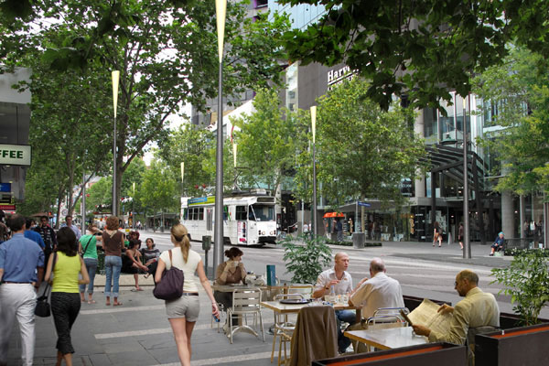

Further and more detailed research on the energy demand of cities would prove invaluable for decision-making in planning and urban design. This research could be at various scales - blocks, suburbs and whole city regions. For urban design purposes an analysis of the energy demand of typical urban tissues would be most useful. With enough studies, rules of thumb could be developed and rough assessments be made of energy demand at the design stage. A new design tool could be born, energy analysis, similar to the financial analysis for large mixed use projects currently undertaken at the Joint Centre for Urban Design, Oxford and by property developers. A necessary first step in this research is the publishing of statistics on energy use at the local level, at present very difficult to find.

Further work is required on how to squeeze low density cities. In Anglo-Celtic societies an anti-urban attitude that contrasts strongly with European and Asian ones lends emotional weight to the growth and maintenance of suburban form and makes squeezing it more difficult. The history of this attitude would be fascinating to unravel, and might provide some useful arguments and strategies for undermining its hegemony in cities like Melbourne. In the USA and Australia at least, extremely low density car dominated cities have a problem of making the control of peripheral growth politically acceptable. Research on strategies and problems of deliberate attempts to achieve higher densities and on cities that are maintaining high densities would be useful.

The study has concentrated on energy efficiency because it is a necessary and non- controversial first step in the direction of sustainability. The per capita energy use required to maintain the present level of consumption of goods and services is probably unsustainable, even using the most energy efficient supply system. Determining the level of energy use that is sustainable is a crucial issue to be researched, although not by urban designers. If present lifestyles are too energy intensive to be sustainable, urban form will need to be more than energy efficient, it will need to be low-energy. The use of ambient energies will be a much more significant shaping force in urban form than in the high-energy efficient pattern proposed here. Dispersed, relatively autonomous small settlements may well prove to offer the most suitable pattern under such conditions. Until the answer to the question of how much energy use is sustainable is known, and even well after, the most important task in the construction of settlements remains the improvement of the energy efficiency of large cities.

References

ABS (Australian Bureau of Statistics) 1986, Census 1986 ABS, Melbourne

Barton, Hugh, 1987 The potential for increasing the energy efficiency of existing urban areas through local planning policy Unpublished M Phil thesis, Department of Town and Country Planning, Bristol Polytechnic

Bentley and others, 1985 Responsive Environments: a manual for designers Architectural Press, London

Brown, Lester and Jodi L Jacobson, 1987 The future of urbanization: facing the ecological and economic constraints Worldwatch Paper 77, Worldwatch Institute, Washington DC

Chapman, P, 1975 Fuel’s paradise Penguin, London

DEA (Danish Energy Agency), 1989 Energy and Denmark: Balance, 1988 DEA, The Ministry of Energy, Landemaerket 11, DK-1119 Copenhagen K, Denmark

DITR, (Department of Industry, Trade and Resources, Victoria) 1988 Victoria's Energy Consumption, 1984-1985 DITR, 250 Victoria Pde., East Melboume, 3002

Hovedstadsradet, 1985 Hovedstadsregionen - et billede i tal,1985 Hovedstadsradet, Skt. Annae Plads 26, DK-1250, Kobenhavn K, Denmark

Lundqvist, L, 1989 Introduction in L Lundqvist and others, (eds.) 1989 Spatial energy analysis: models for strategic decisions in an urban and regional context pp 1-10, Avebury, Aldershot, England

Newman, Peter and Jeffrey Kenworthy, 1989 Cities and automobile dependency Gower Technical, Aldershot, England

Owens, Susan, 1986 Energy, planning and urban form Pion, London

Philleo, Jerryne, 1981 The Davis Energy Book City of Davis, California

