Nathan Alexander

Augusta Street, Glenelg
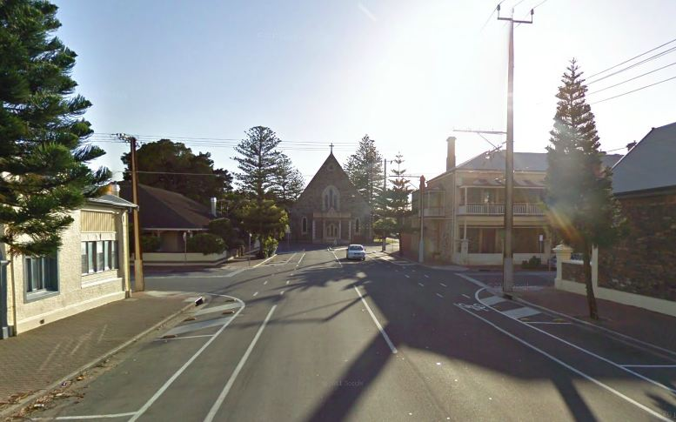
Image from Google Street View

November 2004

www.alexanderurbanism.com

Give me a stimulating setting for every stage of life – give me Augusta Street, Glenelg. Specifically, give me the very western end. You can walk in a minute or two to the beach, shops, cafes and the tram.
Augusta runs parallel to Jetty Road, one block north. The western end is just two blocks long, with the bandstand in Colley Reserve at one end, St Peter’s church in Torrens Square at the other. Given time, the avenues of baby Norfolk Island Pines will one day provide grandeur, unity and shade, as they do in the eastern end of Augusta Street.
Glenelg has more people per square hectare than anywhere else in South Australia. Its heart is Moseley Square, the best used public space in Adelaide. Glenelg beach is a great attraction. The place hums! Augusta’s very close to the action, yet relatively quiet.
The buildings are wonderfully varied in form, age and style. You want charm? Choose between the Victorian cottages, Victorian terrace houses, or a 1920 two-storey apartment building with wonderfully curved external stairways. You want compact? It’s got Edwardian duplexes and 1960 villa units. You want luxury appointments? Check out the eight storey apartment tower circa 2000 and the townhouses circa 2003.
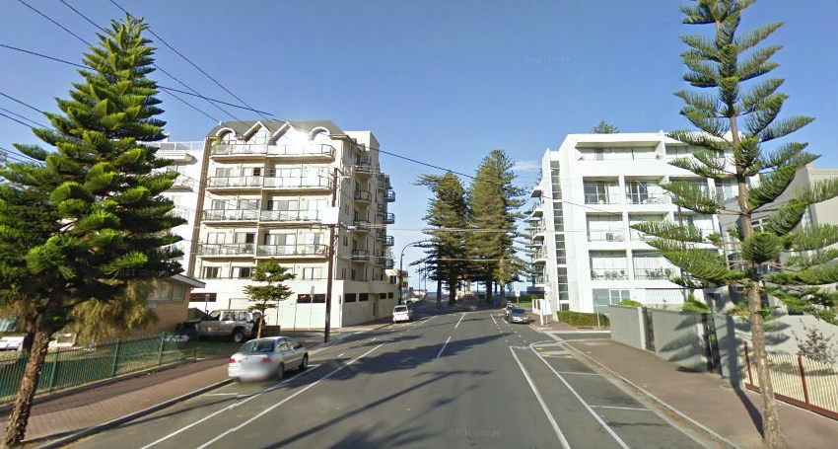
Image from Google Street View
This is not the most beautiful street in Adelaide, the most central, or the easiest to live in. It doesn’t have the nicest houses. The residents are not the most famous, richest or friendliest. It’s not ideal for every household type.
Augusta Street, however, is a great all-rounder. It provides a wide range of housing choice, in a location where the daily necessities are just a stroll away. Great places to eat, exercise, relax and play in are also just a stroll away. A short tram or car ride takes you to the city centre.
As a stimulating setting for every stage of life, give me Augusta Street, Glenelg.

