**Nathan Alexander**

**Metro, anyone?**

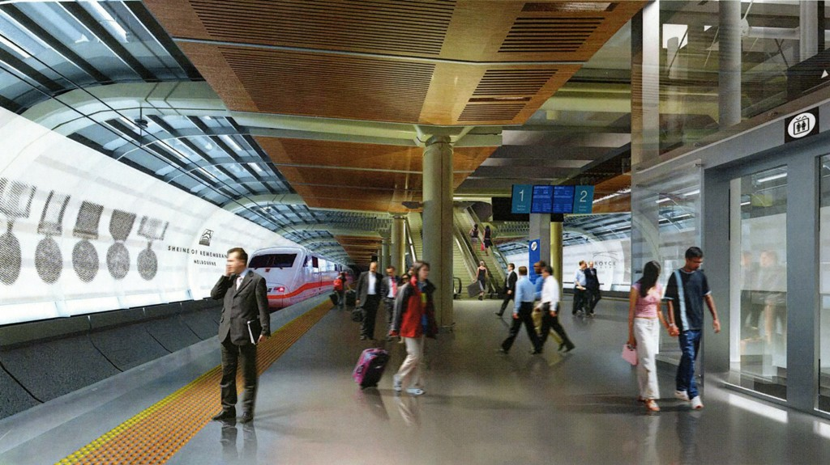

Image by Grimshaw

May 2011

**www.alexanderurbanism.com**

As Australian cities become denser and our urban transport systems reach capacity, metro rail systems offer an efficient transport solution that promotes good urbanism.

What is a metro? It’s a high capacity and high frequency passenger railway service, serving an urban area, powered by electricity and using grade-separated tracks. Each metro line uses exclusive tracks and platforms. Tracks are typically underground, but may be elevated or on the surface. With no level crossings and no other rail traffic, a reliable schedule is easier to achieve. By running at frequencies of less than ten minutes, passengers don’t need to bother with timetables.

No Australian city has a metro, although many Australians will be familiar with them from travel on the New York Subway, the London Underground or the Paris Metro. Instead, Australian cities have trams, buses, cars and ‘normal’ surface trains to move people around.

In Melbourne and Sydney the main roads and the rail networks are at capacity or soon will be. Public transport use has increased 60% in the last decade in Melbourne. Governments in Melbourne, Sydney and Brisbane are spending billions of dollars in new transport infrastructure, especially motorways. Could that money be better spent building metros, and as a by-product creating more walkable urban areas around the stations?

Australian cities already have extensive public transport networks, and the Victorian Government has plans to make Melbourne’s passenger train network more metro-like. It is considering providing exclusive tracks for each line, reducing the number of level crossings and increasing service frequency.

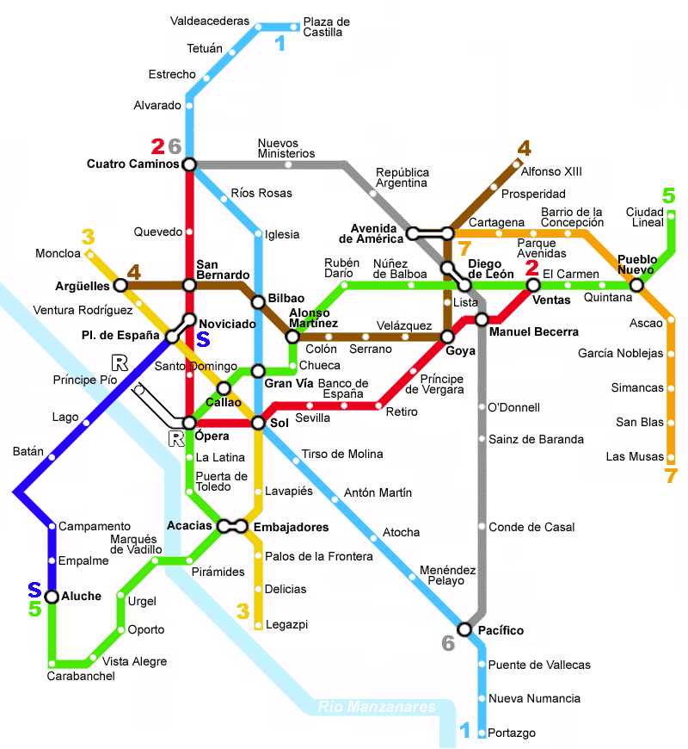Why introduce a metro system? Firstly, different transport modes excel at different trip types. Trams are excellent for short trips and can move up to 15,000 people per hour in one direction on one line. Trains are excellent at long trips, up to 200 km, moving up to 50,000 people per hour. Metros fit in the middle, doing well at moving up to 40,000 people per hour on mid-range trips.

Secondly, as demand increases, each city has to increase the capacity of its transport system. A metro line might well be the best value solution. Thirdly, by taking people out of trams, cars, buses and ‘normal’ trains, a metro will reduce the demand on those systems and decongest them.

New technology allows the creation of a low-cost ‘light metro’ network to serve the middle and inner suburbs. In just ten years between 1997 and 2007 Madrid built 200 kilometres of line and 150 stations for a cost of just $50m per kilometre. Compare that with the $185m per kilometre for the proposed Parramatta-Epping rail link or the $68m per kilometre average cost for Sydney’s 160 kilometres of motorways.

*Map of the Madrid metro system*

Assuming a 25 minute maximum journey time between the centre and periphery, a metro system would have a diameter of approximately 50 kilometres. From central Sydney, that would take in Hornsby, Parramatta and Bankstown, while from central Melbourne it would include Caroline Springs, Craigieburn, Ringwood and Springvale. Lines can be built incrementally and each line can be operated independently and competitively.

Metro lines need high passenger loads. In Australian cities, they would work best connecting several major suburban centres through the city centre. For example in Melbourne, a line might run between Monash University and Tullamarine Airport via Chadstone, Caulfield, South Yarra, central Melbourne, Moonee Ponds and Keilor.

Catching a metro can be as simple as walking from a footpath down one escalator straight onto a platform. Platforms can be as little as 7m below footpath level. With side platforms close to the surface, people can use multiple escalators, stairs and lifts to move easily between the footpath and the platforms. A shallow station with side platforms can have skylights in the footpath to bring natural light and ventilation to the platforms, improving amenity and reducing cost. The need for an underground concourse can be removed if tickets can be validated on the footpath, platform or train, using a stored value card such as Melbourne’s Myki or a remotely-sensed RFID chip system, such as used for tolling on many Australian motorways. Catching a metro could be not much harder than catching a tram!

The stations can be small enough to be built within the street reserve of almost all main streets in Australian suburban and city centres, reducing costs and property impacts. Stations can be contained within a box only 20m wide. Station length will be typically between 60 and 200 m long, depending on the number of carriages designed for. Stations need to be level or almost so, and straight. If stations are too large to fit within the street reserve, in many cases space under the adjoining properties can be used without affecting the buildings above.

Tunnels for a metro can be smaller than traditional rail tunnels, reducing cost and impact. Using small wheels on the carriages and space-efficient power transmission techniques such as solid rod overhead power or third rail powering, internal tunnel height can be 5m or less, unlike the 7m needed for conventional rail tunnels.

Routes could mostly run under main streets and so to a large extent avoid the costs and problems of tunnelling under private properties. Modern technology in tunnelling and trains means that the tunnels can be built very precisely to almost any alignment, and the trains can run up steep slopes. Tunnels can be constructed using cut-and-cover or by very shallow boring.

Balancing the walking catchment, travel times and station costs, the optimum spacing for stations along a line is about 1600m. A grid of metro lines, just like a street grid, spreads the load, provides choice of route and means a blockage at a single point doesn’t block the whole system.

All in all, metros can offer a green transport solution that largely fits under existing public land. Around stations it leads to dense urban form and intensely used pedestrian environments. Sounds like a dream transport system for any urbanist. Metro, anyone?