Nathan Alexander

Neigbourhood character
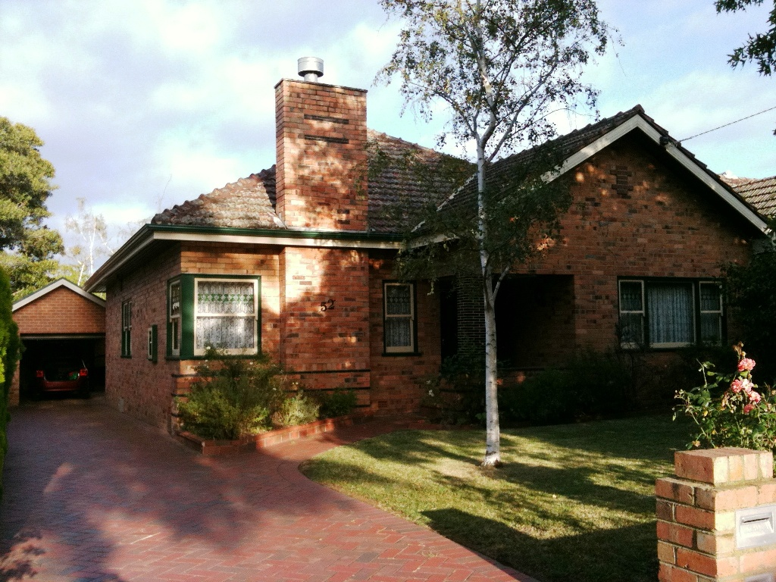

February 2004

www.alexanderurbanism.com

This piece was written for radio. Spoken by Nathan Alexander, it was played on 'Perspective', ABC Radio National, Tuesday 3rd February 2004, between 17:55 and 18:00.
Today I’m going to talk about the issue of neighbourhood character and what I believe should be done about it.
Imagine you live in a neighbourhood of established houses. You’ve been there for twenty years, or maybe just two. You like the street. Lots of single storey houses, big gardens, friendly neighbours. This morning you were woken up by the noise of that place three doors down, that Californian Bungalow with the nice garden, being reduced to a pile of scrap. The neighbours reckon a neo-Georgian-Tuscan-Federation duplex is going up in its place. Two storey, boundary to boundary with almost no yard. It’s an outrage!
According to Save Our Suburbs and similar lobby groups, it’s scenarios like this that’s motivated them to take action. At stake is the future character of our suburbs.
By ‘neighbourhood character’ I mean the ‘look and feel of an area’. That is, what you can see from a street – typically the street, front yards and buildings – and the activity that happens there.
All areas have a character. Each area has a definable, objective character, created by the physical patterns that prevail in that area. It may be that most buildings have a similar height, or the same set back from the street, or a predominance of red brick. Whether we like or hate the character of an area, it can be defined.
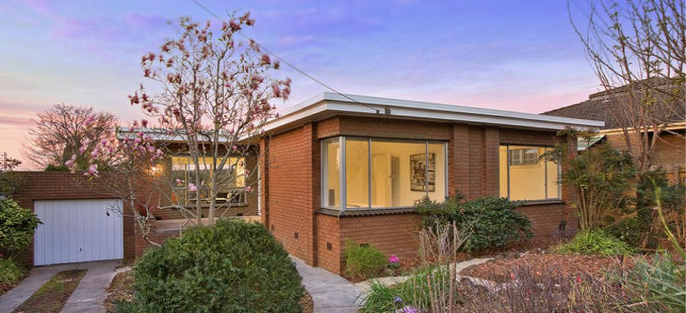

Why has neighbourhood character become such a hot issue in so many Australian suburbs over the last few years? I’ll mention two of the most significant factors at work. Firstly, new houses are on average much larger than they used to be, and many are now double storey. Their visual impact is correspondingly larger. Secondly, more redevelopment is occurring in the middle suburbs of our cities, where there is often a high level of consistency of built form and land use. The result? Potentially we have another ‘tragedy of the commons’, where a public good – a valued neighbourhood character – is diminished.

Now change is inevitable in our suburbs. We can be laissez-faire, and let developers create what they want to. Alternatively, the community can direct change towards a future character of its own choosing. In some cases the local community wants to retain the area’s existing character into the future. In others, the locals want a radical change. In yet others, character is not an issue, and a developer’s free-for-all is fine. In most cases what the locals want is the retention of some elements and a change of others. Messy perhaps, but isn’t that life?
Right now, few Australian local governments have done much work on this issue. Local government is the key institution to handle issues of neighbourhood character because it decides on most development. Clear guidance by local government gives certainty to developers and the community of the quality of development to be achieved. It also reduces the workload of building designers. State government also has a role, by providing appropriate policy.
So, what does local government, the key institution, need to do?
Firstly, local government needs to analyse the existing character of an area street by street to understand the major physical patterns. Secondly, it needs to ask the locals what they value, and what they want for the future.
Next, the council needs to decide on a preferred character – one that’s achievable and that isn’t too complex to communicate. Deciding on a preferred character for an area should take into account the locals’ wishes, but also wider strategic planning issues, such as the ageing of the community and market demand.
Following these steps, local government is ready to prepare a neighbourhood character strategy. This strategy might contain mechanisms such as design guidelines and design review panels. The strategy should guide local government not just in decisions on private development, but for public realm works too, such as street tree plantings. In many streets, it is the street trees that create most of the character.
So, in conclusion, a middle way is available between freezing out development and letting valued character be destroyed by yet another neo-Georgian-Tuscan-Federation box. Local governments can manage character. Local government can resolve with the community a preferred character and a strategy to achieve this. The result - greater certainty for residents and developers, higher real estate values, and well-loved neighbourhoods!

